HI **Mark Bankston**

Hope you are doing good.

We have succeeded to complete many of requirements, except a few, which are mantioned below.   
  
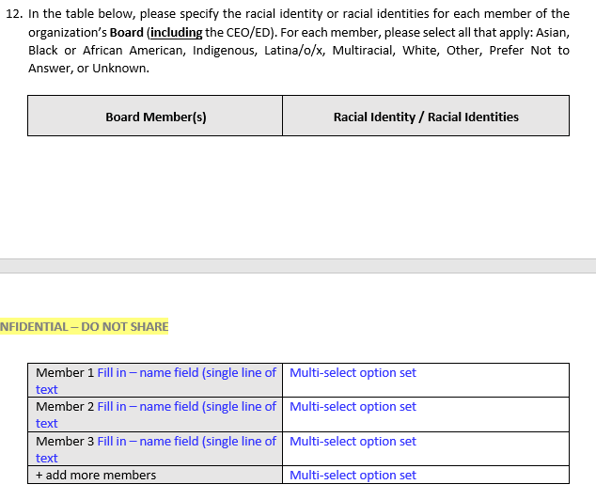

Questions # 10, 12, 17, 19 are pending. We need to discuss regarding these questions, because here we need to save organization members with their Racial or gender information.   
  
Schedule a meeting to discuss.   
  
Thanks